

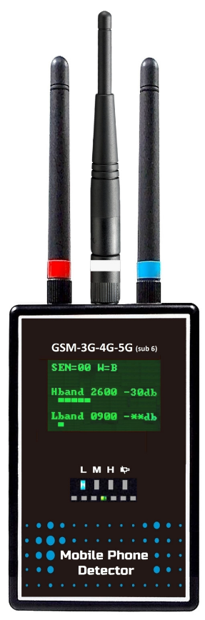CELLBUSTED Model 750

Professional use 2G / 3G / 4G / 5G

**Fix-type LCD Mobile Phone Detector**

0 **Individual frequency band sensitivity adjustment**

0 **Detects 5G sub 6 signal 3300 ~ 3700 MHz range**

0 **Reveals 2G / 3G / 4G / 5G audio monitoring**

0 **Detects 3G / 4G / 5G video monitoring**

0 **Clear LCD display of detected signal**

0 **No interference with signals other than mobile phones**

0 **Anti-cut & power failure alarm output**

0 **Detection warning with NO-COM-NC alarm output**

0 **3-hour backup power with rechargeable batteries**

**Model 750** unit is a professional-grade, fixed-type mobile phone detector designed for locations like prisons where mobile phone use is prohibited. It offers ease of use without complicated settings, making it suitable for individuals without professional electronic training or knowledge.

e INDIVIDUAL FREQUENCY BAND **SENSITIVITY ADJUSTMENT**

This device allows users to fine-tune the sensitivity of each frequency band to accommodate varying distances from base stations. This feature helps eliminate interference from nearby base stations, ensuring effective mobile phone signal detection.

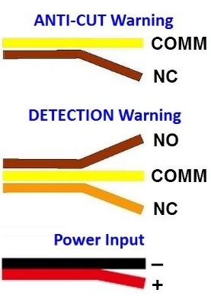

e **DUAL ALARM OUTPUT**

This device features two alarm output options:

1. Anti-cut and power failure warning, triggered through a normally closed

(NC) two-line output when a power failure occurs

2. Detection warning, triggered through a normal open (NO) - COM - normally closed (NC) three-line output when unauthorized mobile phone signals are detected.

e **BACKUP POWER (Rechargeable Batteries)**

This device comes with four AAA/UM-4 rechargeable batteries that provide up to three hours of backup power in the event of a power failure. The battery compartment is located on the rear side and accepts **rechargeable batteries** only.

e **NO INTERFERENCE WITH OTHER SIGNALS**

Designed to specifically detect 2G/3G/4G/5G mobile phone signals, the SH-055UAAF excels at detecting signals in the **3300~3700 MHz** range without interfering with signals from other frequency bands.

e AUDIO **&** VIDEO **MONITORING DISCLOSURE**

In addition to uncovering unauthorized mobile phone use, this device can also reveal unauthorized audio and video monitoring, such as hidden microphones or wireless cameras using 2G / 3G / 4G /

5G mobile phone technology.

e **CLEAR LCD DISPLAY OF DETECTED SIGNAL**

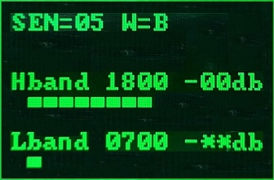

The LCD screen displays the frequency band, signal strength (dB value), and signal strength bars of detected mobile phone signals. Users can choose from three sensitivity benchmarks and adjust them according to the detection range, allowing for customized detection distances.

|  |  |  |
| --- | --- | --- |
| **No.** | **Display** | **Description** |
| 5 |  | Detected band |
| 6 |  | Detected signal strength |
| 7 |  | Signal strength bar |

|  |  |  |
| --- | --- | --- |
| **No.** | **Display** | **Description** |
| 1 |  | Sensitivity level |
| 2 |  | Warning mode |
| 3 |  | High band |
| 4 |  | Low band |

e **SENSITIVITY BENCHMARK & LEVEL**

|  |  |  |  |  |
| --- | --- | --- | --- | --- |
| **Sensitivity Benchmark** | | **Level** | **Sensitivity Level** | **Sensitivity Tuner** |
| L (**L**ow) |  | 00 - 09 |  |  |
| M (**M**edium) | 10 - 19 |
| H (**H**igh) | 20 -29 |

1. This device has Low, Medium, and High three benchmarks. The user can set the sensitivity benchmark according to the range to be detected. For example, when detecting a big room or a high ceiling room, setting the benchmark at High can get a longer detection distance of up to 20 meters radius.

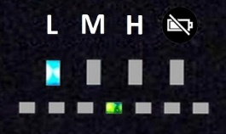

To detect a small area, such as a prison cell or a meeting room, setting the benchmark at Low can get a shorter detection distance of up to a 5-meter radius. Then it is not easy to detect the mobile signals from the next room. * The detection distance will vary depending on the signal strength.

2. After entering sensitivity adjustment mode, press the ＋ **or** － button on the left side to change

the sensitivity level. Sensitivity levels 00 - 09 are the Low benchmark, 10 - 19 are the Medium benchmark, and 20 - 29 are the High benchmark.

3. Each of the three benchmarks has ten (10) sensitivity levels for users fine-tuning the detection distance. When detecting mobile phone signals, lower the sensitivity, level by level, to get closer to the signal source.

e **DETECTED FREQUENCY BANDS ( Hband, Lband)**

|  |  |  |
| --- | --- | --- |
|  | High band | 1700, 1900, 2600, 3500/3600 MHz |
|  | Low band | 700, 800, 900 MHz |

1. For the 5G Sub-6 frequency band, a range of 3300 to 3700 MHz is displayed as **3500**.In the case of models designed for use in European countries, the operating frequency bands, 3400 ~ 3800

MHz, are displayed as **3600**.

2. When multiple frequency bands of mobile phone signals are present simultaneously, only the frequency band with the strongest signal strength will be displayed on the screen.

e **SIGNAL STRENGTH & STRENGTH BAR**

1. Signal strength is displayed in dB values, with **-**＊＊**db** = No mobile phone signal detected

2. Signal strength display bar: Total 8 bars representing 7 levels of signal strength

|  |  |  |  |
| --- | --- | --- | --- |
| **No.** | **Signal strength** | **Display bar** | **Display** |
| 1 | -＊＊db | 1 |  |
| 2 | -60db | 2 |
| 3 | -50db | 3 |
| 4 | -40db | 4 |
| 5 | **-30db** | **5** |
| 6 | -20db | 6 |
| 7 | -10db | 7 |
| 8 | -00db | 8 |

e **WARNING MODES**

The default warning mode is "B" (Beep + Relay output), with the option to switch to "S" (Relay output) if preferred.

|  |  |  |
| --- | --- | --- |
| **B** | Beep + Relay output |  |
| **S** | Relay output |

e **EASY SENSITIVITY ADJUSTEMNT**

1. This device comes with a default sensitivity level of 15, suitable for detecting signals within an

8-meter radius. Users can adjust sensitivity to eliminate interference and adapt to different detection scenarios, such as different floors in a building.

2. Upon activating this device in the detection area, begin by moving the device around to determine the presence of any mobile phone signals.

3. When a mobile signal is detected, the device's LCD screen will showcase the frequency band, signal strength level (in dB), and strength bars of the identified signal. In cases where mobile signals of various frequency bands are detected within the same detection area, it is likely due to environmental noise or interference. To address this, adjust the sensitivity for each detected frequency band to eliminate any interference.

4. If you are conducting detection in a building, this device will identify mobile phone signals on both upper and lower floors. Adjust the sensitivity level accordingly to mitigate potential interference.

5. To enter sensitivity adjustment mode, simultaneously press the + and - buttons on the left side of the device. The green scan LED will remain on the first channel, and the LCD screen will display an asterisk (*) next to the Lband 0700, indicating that the 700MHz frequency band is currently being adjusted. The upper-left corner of the screen will show SEN = 15, representing the factory default sensitivity level. If the user has previously set a different sensitivity level, it will be displayed accordingly.

6. Increase the sensitivity level by pressing the + (plus) button once, or decrease it by pressing the

- (minus) button once.

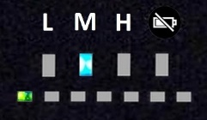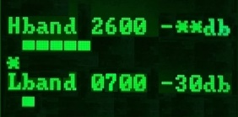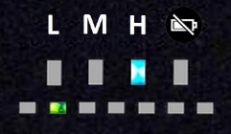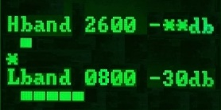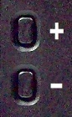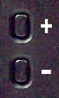

|  |  |  |  |  |  |
| --- | --- | --- | --- | --- | --- |
| Sequence | Simultaneously press the + and - buttons on the left side | The green scan LED  remains on the first channel | | The LCD screen displays an asterisk (*) next to Lband 0700 | |
| **1** |  |  | |  | |
| Default sensitivity level is SEN=15 | Press the + button once to increase sensitivity by one level |  | | The sensitivity level changes to SEN=16 |
|  |  |  |

|  |  |  |  |  |  |
| --- | --- | --- | --- | --- | --- |
| Sequence | After adjusting the sensitivity of the 700 band, press the + and - buttons simultaneously | The green scan LED switches to the second channel | | The LCD screen shows Lband  0800 with an asterisk (*) | |
| **2** |  |  | |  | |
| If the previous sensitivity level was SEN=20 | Pressing the - button once reduces it by one level |  | | The sensitivity level changes to SEN=19 |
|  |  |  |

7. Follow the methods outlined above to complete the sensitivity level adjustment for the 700 →



800 → 900 → 1700 → 1900 → 2600 → 3500 (3600) frequency bands. After adjusting the

last band, which is 3500 (3600), press both the + and - buttons on the left side simultaneously. This action will exit the sensitivity adjustment mode and return the device to normal detection mode.

e **DETECTING FREQUENCY BANDS**

This device is equipped to detect frequency bands of 700, 800, 900, 1700, 1900, 2600, and 3500 (3600) MHz. Custom manufacturing options are also available to align with the specific frequency bands of various countries or regions.

e **STANDBY / IDLE PHONE REGISTRATION DETECTION**

When the signal strength of base station weakens, the cellphone will re-scan the base station to do new registration automatically. Or the base station will initiate registration on its own by sending a signal to the cell phone, causing the phone to transmit and identify itself.

This device can detect the standby / idle phone when it registers with the base station. The interval time and number of times of registration differ among different networks and cell phones.

e **TURN OFF SPECIFIC FREQUENCY BAND**

If you do not need to detect a specific frequency band or only want to detect certain frequency bands, set the sensitivity level to 00 and press the minus (-) button again, the device will beep three times to confirm the deactivation of the selected frequency band.

e **SPECIFICATION** * Specification may change without prior notice.

|  |  |
| --- | --- |
| **Dimension** | L 11.6 x W 7 x T 3.3 cm (not including antenna length) |
| **Weight** | About 215g |
| **Power** | 5V DC input with AC power adaptor included |
| **Power Consumption** | 0.2A (200mA) per hour |
| **Backup power** | AAA NiMH rechargeable battery x 4 included for portable use |
| **Backup power available time** | 3 hours after full charge |
| **Detecting Frequency** | 700, 800, 900, 1700, 1900, 2600, 3500 (3600) MHz |
| **Sensitivity Level** | 00 ~ 29 total 30 levels |
| **Signal Strength Indication** | 8 signal strength bars represent 7 signal strength levels |
| **Alarm output**  **(1.0A relay)** | Anti-AC power cut & power failure warning, with NC output |
| Detection warning, with NO-COM-NC relay contacts output |
| **Warning modes** | 1. Beep + Relay output |
| 2. Relay output |

**FREQUENCY BANDS COVERED**

|  |  |  |
| --- | --- | --- |
| No. | Cellphone  Networks | Frequency Range |
| 1 | 700a | 699 ~ 716 |
| 2 | 800 | CDMA 824~845 |
| 3 | 900 | 890~915 |
| 4 | 1700 | 1710~1755 |
| 5 | 1900 | 1850~1910 |
| 6 | 2600 | 2500~2570 |
| 7 | 3500 | 5G:3300~3700 |

|  |  |  |
| --- | --- | --- |
| **Fixed-base/ office type unit**  **LCD Screen For Professional use**  **2G_3G_4G_5G**  **Mobile Phone Detector Comes With:**  1. Detector  2. Switching power adaptor// Battery charger  3. Mini USB cable  4. Rechargeable battery (AC power backup/ portable)  5. Earphone | | - With dual alarm output BEEP and  -Relay contacts for remote alarming  - **5V DC** power input with AC supply |
| **Model No.** | **CELLBUSTED 750** |
| **Q’ty** | **Unit Price (Ex-Works)** |
| <5 | @US$785.00 |
| >5 | US$700.00 |
| 10 | US$650.00 |

CELLBUSTED

22826 MARIPOSA AVE.

TORRANCE, CALIFORNIA 90502 USA

PHONE 310.534.4456

WWW.CELLBUSTED.com